**Events**

An event is an occurrence that triggers or creates a task or activity. Usually all business process maps and models will have a start event and an end event, but they can also have intermediate events that redirect the flow to a different path.

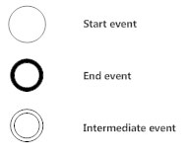

There are many different types of intermediate events. Below is a table that showcases the wide range available in BPMN notation.

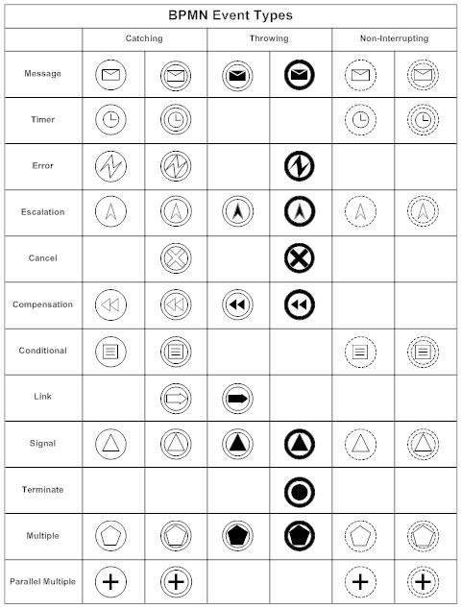

Message events are calls, emails, letters, or any communication that initiates a task.

Timer events are useful for inserting breaks that may interrupt the flow. These breaks allow you to display tasks that repeat at some frequency like hourly, daily or weekly. You can show how long a task may take or show a specific date (or time) a task is to start.

Conditional events will interrupt the flow until a condition is met.

Signal events are not addressed to any particular participant but are visible globally. For example, a signal event would be a customer seeing an ad on social media before calling to place an order.

Error events are used in analysis. They're not naturally part of any process. The notation may help discuss any potential problems in your process.

Cancel events are only appropriate for transactional activities.

Link events, like error events, don't describe a part of the process but are helpful while diagramming complex systems. Instead of connecting activities with lines, they can be used to link to activities if you want to have a physical distance between them.

**Activities**

Activities are tasks that must be executed during the process. They can be performed by an individual or the system. An activity is depicted with a rectangle with rounded corners. Activities can have sub-processes, loops, multiple instances, and compensations.

A sub-process is a set of activities that can show a task in more detail. For example, the activity "deploy web page" may include the sub-tasks of checking it into a source control, merging code to the production servers, and copying from production to the live servers. A collapsed sub-process is depicted with a small plus sign on the activity symbol and the sub-process is visualized in a separate diagram.

A loop repeats until one or more conditions are met.

An activity with multiple instances means all subtasks must be completed before proceeding to the next task. These instances can be executed in sequence or in parallel. For example, you might model a process during which 3 stakeholders have to approve an outline before a video can move into production. Those three approvals would be an activity with multiple instances.

A compensation event appears in the process in response to something that needs undoing such as a cancellation or denied authorization.

A transaction activity is a special type of process used for payment.

A call activity is a reusable sub-process throughout the entire system.

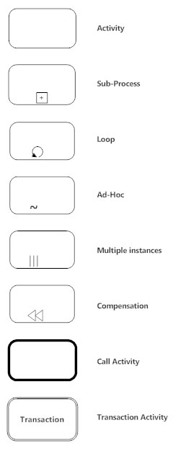

**Gateways**

Gateways depict a decision step, a point of convergence or divergence of flow in the process. They can be exclusive or inclusive, parallel, complex, or based on events or data.

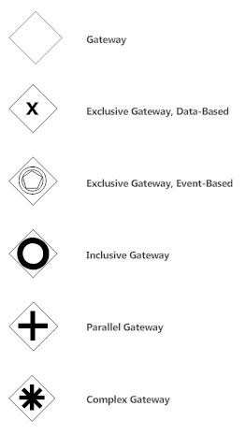

An X inside a gateway symbol indicates a decision between mutually exclusive choices. In programming terms, this is an "or" event. The flow will travel down only one path.

A parallel gateway, indicated with a plus sign inside a diamond, requires that the process continues to flow in both directions from the decision point. We basically want to have our cake and eat it too. This is an "and" event.

An inclusive gateway allows the flow to travel down more than one outgoing path.

Event based gateways are triggered by events rather than conditions, for example a message, elapsed time, a signal, and so on.

**Flows**

Flows connect the activities that are part of a business process. These connections are meant to indicate relationships.

A sequence flow is the most frequently used flow type shown as a straight line with an arrow. This type of flow indicates the sequence in which tasks are executed.

A message flow depicts the flow of messages from one participant to another. It is shown with a dashed line with a circle on one end and an arrow at the other. Make sure messages don't connect activities or events in the same pool. Never attach a gateway symbol to a message flow.

An association, represented with a dotted line (sans arrow), is used to show a relationship between an artifact like data and tasks on your diagram.

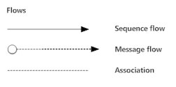

**Artifacts**

Artifacts are not part of the process, but may be relevant to it. These are usually annotations or data.

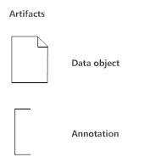

Using Swim Lanes to Define Participants in BPM

Lanes help define roles, functions, and responsibilities more clearly. Each lane represents a role and the tasks they're responsible for executing.